0.00 6.88 HOST Two uninhabited Pacific Islands.

6.88 13.08 HOST More than 5,000 miles from the UK.

13.08 22.80 HOST One will be inhabited by 14 British men, while a separate island will be home to 14 British women.

22.80 30.96 HOST When pushed to the limits of human endurance, will it be brute power or mental strength that wins the day?

30.96 36.36 HOST Who will have what it takes to stay alive?

36.36 43.08 HOST Tonight we follow the men.

43.08 51.40 HOST Britain today, we've never been further from our hunter-gatherer origins.

51.40 57.68 HOST But I want to know when stripped of everything, has modern man still got that instinct to survive?

57.68 64.52 HOST To find out, im marooning 14 ordinary men on a desert island.

64.52 67.48 PAUL_36: This is crazy, this is absolutely crazy.

67.48 70.24 PAUL_36: This could be the worst decision we've ever made.

70.24 73.52 HOST This time it will be harder than ever.

73.52 80.16 HOST They'll have to endure six weeks in height of a harsh tropical storm season.

80.16 83.96 VIC_47: Bring me on, I say if this is the worst you can do.

83.96 87.92 HOST They will be utterly alone, filming everything themselves.

87.92 89.72 PAUL_36: We have two choices.

89.72 92.40 PAUL_36: One we go down the 40 foot ravine.

92.40 93.80 PAUL_36: Holy shit.

93.80 98.16 PAUL_36: Well we keep going through this asshole of a jungle.

98.16 103.56 HOST They'll have to find their own water and hunt for their own food.

103.56 106.80 VIC_47: We just caught a prehistoric animals.

106.80 110.80 SPEAKER? You lazy bunch of bone idol bastards.

110.80 117.80 HOST Have these modern day men got what it takes to survive?

117.80 129.52 PAUL_36: That's the hardest thing I've done.

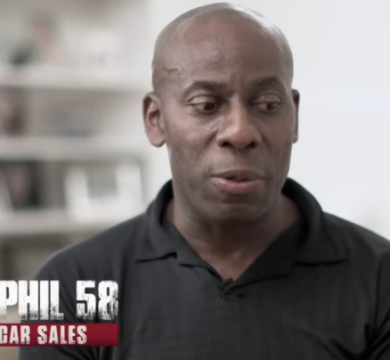

**</intro**>

129.52 145.76 PHIL_58 : I personally don't think men are as strong now as they were, I wouldn't even say 50 years ago, even five years ago. **to:camera**

145.76 147.48 PHIL_58: Because we have it too easy. **to:camera**

147.48 152.64 PHIL_58: The interesting question to ask actually is if we lost everything what would happen to us? **To:camera**

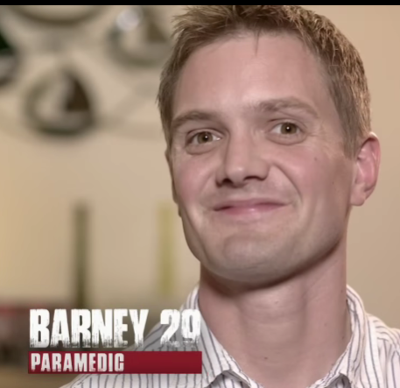

152.64 162.64 BARNEY_29: It would be nice to think I've come off the island feeling a little bit more macho, a little bit more alpha male, a little bit more popular with the ladies. **to:camera**

162.64 170.44 HOST I'm about to abandon these men on a remote Pacific island to see if they can survive.

170.44 171.84 HOST They will be utterly alone.

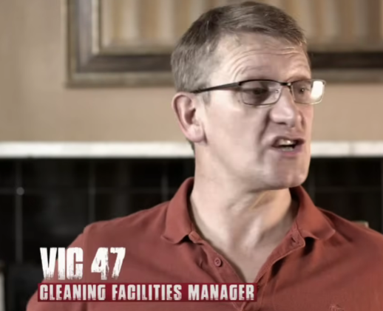

171.84 175.72 VIC_47: My oldest last 19 is at university, he only needs me for money and a lift. **to:camera**

175.72 178.00 VIC_47: And the only response is too cool to run around with dad.

178.00 183.20 VIC_47: My dream is for them guys to go that's my dad, that's fantastic, my dad did that.



184.20 187.64 JOE_22: I don't think I've done anything that's put myself at risk really. **to:camera**

187.64 192.20 JOE_22: But I'm scared he's sticking a graph of his island on an island with no other skills whatsoever. **to:camera**

192.20 194.04 JOE_22: Anything could happen. **to:camera**

194.04 200.08 HOST These 14 ordinary men do not know each other and they have no experience in living in the wild.

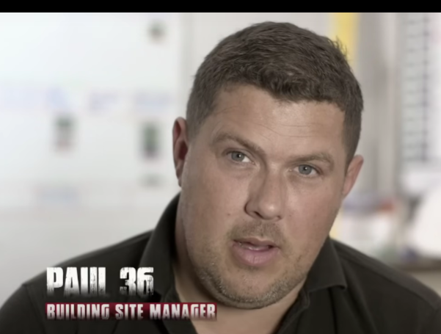

200.08 203.44 PAUL_36: At the moment I don't enjoy day to day life. **to:camera**

203.44 211.00 PAUL_36: I've got a stressful job, I've got a newborn baby at home, I want to go out on the island to get away from the day to day bullshit. **To:camera**

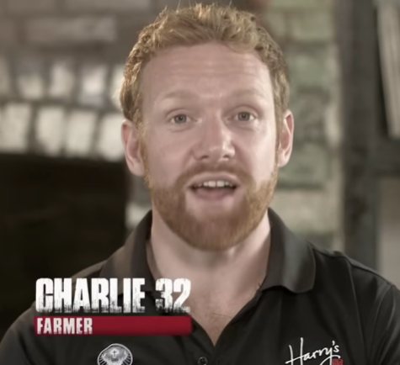

212.00 214.44 CHARLIE_32: I think everyone in life does take certain things for granted. **To:camera**

214.44 217.92 CHARLIE_32: Electricity when you turn on the light, having a warm shower, having breakfast. **To:camera**

217.92 222.76 CHARLIE_32: When it's not there and you wake up in the morning and go, where's the next meal coming from? **To:camera**

222.76 223.76 CHARLIE_32: It's a man test isn't it? **To:camera**

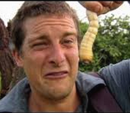

223.76 226.76 HOST Okay guys we're getting closer.

226.76 228.76 HOST You are very remote here.

228.76 233.28 HOST The next stop that way is New Zealand.

233.28 245.64 HOST What I want to find out is, has all of this cushioning that civilization has experienced over the last 50 years made us totally lose touch with that survival instinct that I believe is deep within us all. **To:camera**

245.64 250.88 HOST Okay guys I need you to be my eyes for any rocks, there are loads of rocks here. **To:all**

250.88 256.36 HOST It takes an extreme situation to find out what people are really made of.

256.36 263.84 HOST What you're about to embark on, it will be the toughest thing you will ever do. **To:all**

263.84 265.92 HOST You can do this, alright?

265.92 266.92 HOST You can do it. **To: THE MEN**

268.72 275.60 HOST The men's home for the next six weeks is an uninhabited island in a remote Pacific archipelago. **To: narration**

275.60 284.40 HOST The 11km of coastline is dominated by treacherous cliffs and rocky headless.

284.40 289.32 HOST Fisher swells and powerful ocean currents means there's no easy way onto the island. **To: narration**

289.32 293.88 HOST I'm going to try and get you guys as close as I can, alright? **To:all**

293.88 296.76 HOST But you will end up swimming.**To:all**

296.76 301.00 HOST I'll give you guys are weak swimmers, it is a good time to say.**To:all**

301.00 305.76 PHIL_58: I've never swam this distance before, not even in a swimming pool, but I will get there.**To:all**

305.76 307.08 PHIL_58: Age won't stop me doing this.**To:camera**

307.08 316.12 PHIL_58: Not often in one's life someone actually challenges your morals, challenges you physically and this does, that's why I want to do it. **To:camera**

316.12 318.32 PHIL_58: Who can't swim confidently?

318.32 319.88 PHIL_58: Confident with unconfident, yeah?

319.88 320.88 PHIL_58: Let's go.

320.88 321.88 SPEAKER_15 (old guy) Woo hoo!

322.88 328.88 HOST The men must make the 75m swim to the island fully clothed.

328.88 331.88 HOST Help each other, help those who are weaker. **To:all**

331.88 332.88 HOST Get off the back, get off the back. **To:all**

332.88 333.88 HOST Let's go, let's go. **To:all**

337.88 341.88 HOST Strong undercurrents mean the men need to get to shore as quickly as possible. **To:narration**

341.88 343.88 HOST Kitty!

343.88 345.88 HOST You're doing good, go on mate.

345.88 347.88 HOST Keep going, keep going.

347.88 350.88 HOST Go, go, go, go.

356.88 359.88 VIC_47: That was the damnedest thing I ever did.

361.88 363.88 SPEAKER_16 I couldn't have gotten much better.

363.88 366.88 SPEAKER_16 Well that's only a taste of what we got to come then.

366.88 368.88 SPEAKER_16 Bring it on more than nature. **To: ?**

369.88 371.88 SPEAKER_07 Hey, what are you doing? **To: barney**

371.88 376.88 BARNEY_29: Well the advice is to save your own pits, which is a bit unnerving. **To:camera?**

376.88 380.88 HOST With only two days survival training, initiative will be key.

380.88 382.88 BARNEY_29: Essentially it's water isn't it? **To:camera**

382.88 383.88 PAUL_36: Is that your piss mate?

383.88 384.88 SPEAKER_07 You're not saving anything are you?

384.88 386.88 PAUL_36: Yeah, yeah, saving your piss.

386.88 387.88 PAUL_36: You're not being told anyway.

387.88 388.88 PAUL_36: Save your piss.

388.88 389.88 BARNEY_29: Drink your own piss? **To:camera**

389.88 390.88 BARNEY_29 I hope not. **To:camera**

390.88 394.88 HOST So they look a bit like a part of drowned rats at the moment. **To:cam**

394.88 396.88 HOST Kind of let the chaos begin.

396.88 409.88 HOST But what I do know is when I return in six weeks time, the 14 men, if there's still 14 men there, which to be honest, I doubt. the men that do remain will be changed. **To:cam**

410.88 413.88 HOST It's time for me and the crew to leave. **To:cam**

413.88 416.88 HOST We won't be back until the end of the experiment.

418.88 423.88 HOST For the next six weeks, the men will have to live entirely on their own wits.

424.88 434.88 HOST To make sure these men at least have a fighting chance of survival, I've ensured the island's got enough water, indigenous animals and vegetation on it to keep them alive. **To:cam**

434.88 441.88 HOST It's teeming with wildlife, but what they've got to have is an ingenuity to find it, catch it and kill it. **To:cam**

441.88 442.88 PAUL_36: Pushing him in. **To:cam**

442.88 443.88 SPEAKER_07 Can you get in?

443.88 444.88 HOST Pull, pull, pull.

444.88 445.88 HOST That's all right.

445.88 450.88 HOST From here on in, everything you see will be filmed by the men themselves.

451.88 462.88 PAUL_36: Why don't we get everybody together and then we're just all doing we're workout something that we're going to do and then we're all going to be heading that way, I'm assuming anyway, because it looks a little bit safer than this. **To:all**

462.88 464.88 PAUL_36: It'll be dark soon.

464.88 467.88 SPEAKER_07 Come on, lads, let's make use of some of this energy while we've got it.

467.88 472.88 HOST All of the men will film before the group are trained and experienced camera operators.

472.88 475.88 HOST How are you doing, mate?

475.88 479.88 HOST Who'll be living under exactly the same conditions as everyone else.

479.88 482.88 VIC_47: Oh, I'm like a fucking mule, Orsana.

483.88 485.88 VIC_47: The brains of a donkey.

485.88 493.88 PAUL_36: Obviously, because we are having to film everything ourselves, we've got to cart all of the camera gear, batteries and everything with us.

494.88 496.88 PIERS: Let's get on with it.

496.88 499.88 ANDY_BENNETT (51): Fuck's sake, this is survival. Not good morning, Britain.

499.88 509.88 HOST As well as the camera equipment, they'll have a medical kit, two jerry cans containing a day's supply of water, basic fishing equipment and a handful of tools.

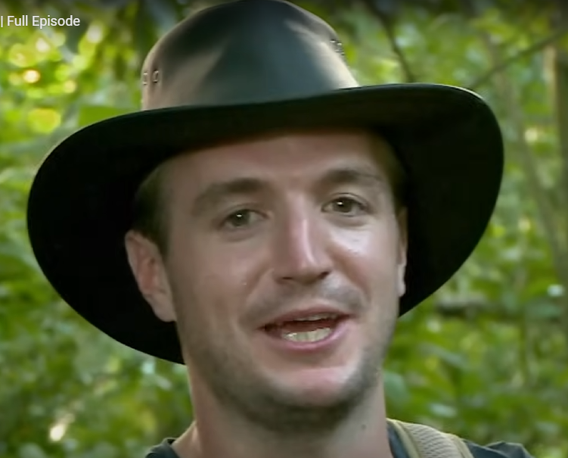

509.88 512.88 PIERS: Guys, how many knives do we have? Let's count them in. **To:all**

512.88 514.88 PIERS: Three knives, three machetes.

**To:all**

514.88 516.88 BARNEY_29: So I'll go the round in one group, guys.

516.88 519.88 BARNEY_29: I'm Barney and I'm a paramedic from Leicester.

519.88 521.88 BARNEY_29: Hello, man.

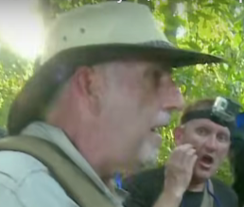

**Note: Everybody cheers as ANDY is a builder**

521.88 523.88 ANDY_BENNETT: I'm Andy Bennett, builder from Milton Keynes.**To:all**

523.88 526.88 SPEAKER_00 We've got a fucking builder, everybody!

526.88 528.88 PIERS: Let’s hope he’s not a cowboy.

529.88 531.88 PIERS: My name's Piers, I am a doctor. **To:all**

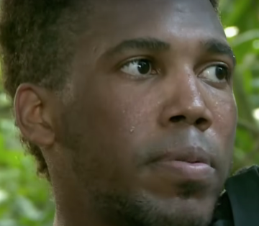

533.88 536.88 KYLE: I'm Kyle and I'm a website consultant. **To:all Note:** No one cheered

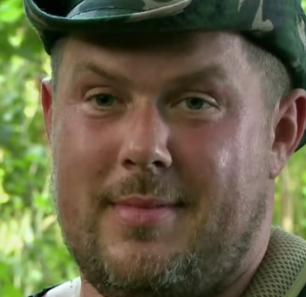

540.88 543.88 PAUL_36: My name's Paul, I invented the dice. **Note: everyone laughed**

546.88 549.88 PAUL_36: I'm a construction contracts manager. **To:all**

550.88 558.88 HOST It's 4pm. With only two hours of daylight remaining, the men's priority has to be finding a safe place to shelter for the night.

560.88 568.88 HOST If they can't, they'll have to sleep rough on the jungle floor, alongside potentially deadly scorpions, snakes and caiman crocodiles.

569.88 575.88 PAUL_36: We're assuming that the north side of the island would be nice beachy, sandy, flat seas. **To: vic**

575.88 578.88 HOST Paul thinks the group's best option is a beach.

578.88 580.88 PAUL_36 Let's go.

580.88 584.88 HOST And he's convinced they have time to cross the island to find one before dark.

586.88 590.88 JOE_22: Who else was imagining sunny beaches when they thought about coming out here?

590.88 592.88 JOE_22: These trees here are very sharp.

593.88 595.88 PAUL_36: There you go.

595.88 599.88 PAUL_36: I believe it will now be referred to as the porcupine tree. Vicious.

600.88 606.88 HOST The interior of the island is three square kilometres, a mangrove swamp, an unbroken jungle.

606.88 613.88 HOST And I know from experience that moving through dense island undergrowth is slow, exhausting work.

613.88 616.88 HOST It will do all you can to stop you in your tracks.

616.88 620.88 HOST And often the harder you push, the harder it pushes back.

620.88 622.88 PAUL_36: Whale, stop!

624.88 626.88 SPEAKER_07 There's a snake down here. **To: paul**

626.88 628.88 SPEAKER_07 It's a boa, isn't it? **To:**

628.88 631.88 SPEAKER_07 Take its head off if it's a decent size, mate. Get stuck in.

631.88 633.88 PAUL_36: Is anyone going to help me?

633.88 636.88 PAUL_36: I'm trying to carry a bag and a machete and kill a snake.

636.88 639.88 SPEAKER_07 : He's looking pretty aggressive. He's coiling, isn't he? **To: paul**

639.88 642.88 PAUL_36: I need a long stick just to put on its head.

642.88 646.88 PAUL_36: Mind you, no, don't, don't, don't, don't, don't do that, for fuck's sake. **To: JOE_22**

646.88 648.88 ANDY_BENNETT: Listen, shall we just throw this case on it? **To: joe and paul**

648.88 651.88 JOE_22: No. Part of me thinks, shall we just leave it? **To: Andy and paul**

651.88 654.88 PAUL_36: Didn't even flinch, did it? **To: joe to andy**

654.88 656.88 JOE_22: Yeah, yeah, lets keep going. **To:paul**

657.88 661.88 JOE_22: If we don't get out of this shrub, we're going to be sleeping here tonight. **To: cam**

661.88 663.88 JOE_22: Ain't safe and it's not cool. **To:cam**

664.88 670.88 HOST With just an hour to go until nightfall, the men have covered barely 400 metres.

670.88 672.88 VIC_47: Paul! Yes? **To: paul**

672.88 674.88 PAUL_36: You're going to come and get a drink?

674.88 677.88 PAUL_36: The darker it's getting, the more it's getting a little bit worried. **To: camera**

677.88 678.88 VIC_47: Is that funny when you're done?

678.88 682.88 PAUL_36: Somehow I've fallen into chief navigator mode, but I'm on it. **To:camera**

683.88 685.88 PAUL_36: My days are very stressful. **To:camera**

686.88 689.88 PAUL_36: It really doesn't fucking matter. I don't give a fuck. **To:camera**

689.88 692.88 PAUL_36: A lot of the time I think that most people are fucking idiots. **To:camera**

692.88 694.88 PAUL_36: Just get that load, yeah? Get that load, yeah? **To:camera**

694.88 696.88 PAUL_36: You can't build the internal walls anyway. **To:coworker**

696.88 702.88 PAUL_36: Being called a bastard is just a sort of friendly greeting in the building industry. **To: cam**

702.88 704.88 PAUL_36: Get in there and get it done. **To:cam**

704.88 707.88 PAUL_36: This experience might change me.

707.88 711.88 PAUL_36: Hopefully for the better it might make me be a little bit more tolerant of other people.

711.88 713.88 PAUL_36: Come on, fuckers.**To: all**

714.88 716.88 PAUL_36: This is going to take us fucking hours.**To: all**

716.88 718.88 JOE_22: Yeah, it's about to get darker and darker as well.

718.88 721.88 PAUL_36: Yeah, I know. So that's why we've just got to get through it. **To: joe**

721.88 729.88 JOE_22: We need to start to think, do we want to be hacking through this stuff when it's pitch black, or at the next time we see a clearing, are we going to think about settling down for the night? **To: paul**

729.88 732.88 PAUL_36: I personally want to just plough on and make it. **To:joe**

732.88 736.88 PAUL_36: I mean, it's going to get darker in here quicker than it is on the beach. **To:joe**

736.88 738.88 PAUL_36: I say we plough on.**To: joe**

738.88 741.88 JOE_22: This is crazy. This is absolutely crazy. **To:camera Note: Upset**

744.88 746.88 JOE_22: I haven't had to say right now. **To:cam**

748.88 750.88 JOE_22: I never had the money to go travelling. **To:cam**

750.88 755.88 JOE_22: I never done anything that's been a bit sort of edgy, that's been a bit… **To:cam**

755.88 757.88 JOE_22: dangerous, I guess.**To:cam**

757.88 763.88 JOE_22: I don't think I'm as confident as I say I am, and I think a lot of what I do can be a front. **To:cam**

763.88 768.88 JOE_22: The sort of persona of Alpha Male to me is everything my stepdad was.**To:cam**

768.88 771.88 JOE_22: I saw enough of him growing up to realise who not to be.

771.88 774.88 JOE_22: I guess it's time to find out who I really am. **To:cam**

774.88 777.88 PAUL_36: Keep coming, we're only 100 metres away! **To:all**

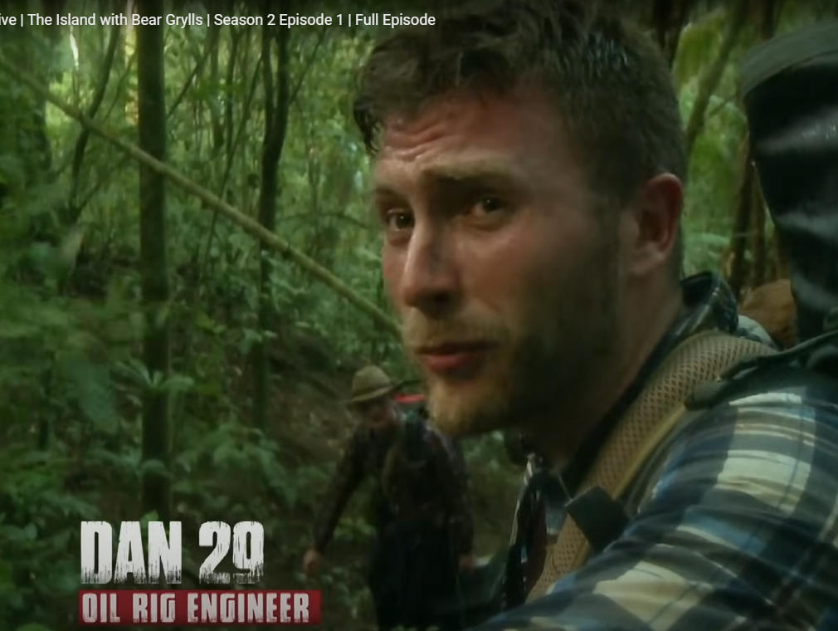

777.88 786.88 DAN_29: I keep seeing things like the beach is a little bit bigger, so I'm getting a little bit pissed off because I've been walking through about fucking miles, and it's not here. **To:cam**

786.88 788.88 DAN_29: The tempers are free. **To:**

788.88 793.88 HOST At the back, 51-year-old builder Andy is struggling to keep up.

793.88 796.88 ANDY The line looks like every man for himself. **To: cam**

796.88 798.88 ANDY_BENNETT: For fuck's sake.

799.88 801.88 ANDY_BENNETT: First cut. **Note: Injured**

805.88 810.88 JOE_22: We've neither made any ground, and we are all fucked. **To:cam**

810.88 813.88 VIC_47: Joe, fuck Randy and help, yeah. **To: Joe**

813.88 816.88 VIC_47: He's got a really awkward box on his own.**To: Joe**

816.88 819.88 VIC_47: I know it's symbolic, but you're carrying one of the fucking easiest things in the world. **To: Joe**

819.88 821.88 VIC_47: I'm not fucked. **To: Joe**

821.88 823.88 VIC_47: I know it's heavy. **To: Joe**

823.88 825.88 JOE_22: But it's heavy. **To: Vic**

825.88 827.88 JOE_22: You want to carry this bag? **To: Vic**

827.88 829.88 JOE_22: Fucking hell, mate. Go on. **To: Vic**

**Note: Joe and Vic arguing, Vic wants joe to help Andy Bennet**

832.88 837.88 HOST At the front, Paul pushes on, despite the group's growing descent.

**Paul is leading the group, rest is falling behind**

838.88 840.88 ANDY_BENNETT: Have we got lights in those cameras, Sam?

840.88 842.88 SAM: Bit of infrared.

842.88 843.88 SAM: How are you doing, mate?

843.88 845.88 ANDY_BENNETT: Some people ain't playing ball.

845.88 847.88 SAM: What way? What do you mean?

847.88 849.88 ANDY_BENNETT: Cracking on with fuck all, you know?

849.88 852.88 ANDY_BENNETT: We could all do that like a hero with a machete.

852.88 854.88 ANDY_BENNETT: Come on, for fuck's sake.

854.88 857.88 ANDY_BENNETT: I know we all want to get on, but...

857.88 859.88 ANDY_BENNETT: You've got to think of everybody else now we're a team.

859.88 862.88 ANDY_BENNETT: You can't just be selfish, you know?

**Note: Andy beefing with Paul, dislikes that Paul isn’t waiting for the rest of the group**

863.88 865.88 BARNEY_29: What, is it a bit of light? Look. **To: cam**

865.88 867.88 BARNEY_29: Ha! This is amazing. **To: cam**

867.88 869.88 PAUL_36: I found the sea.

869.88 871.88 PAUL_36: Ha!

871.88 873.88 PAUL_36: Ha!

873.88 875.88 PAUL_36: Ha!

875.88 877.88 PAUL_36: Ha!

877.88 879.88 PAUL_36: Ha!

879.88 881.88 PAUL_36: Ha!

**Arrives at beach**

881.88 883.88 SPEAKER_01 Ah! To go beach!

883.88 885.88 SPEAKER_01 Come on!

885.88 886.88 SPEAKER_01 We're all going!

886.88 888.88 SPEAKER_01 Come on!

888.88 889.88 PIERS: Oh, yeah!

889.88 890.88 PIERS: Beach!

890.88 892.88 SPEAKER_07 Pina coladas.

899.88 901.88 None Oh, yeah.

902.88 905.88 PAUL_36: That's the hardest thing that I've done? **To: cam**

906.88 908.88 JOE_22: Ah!

908.88 910.88 JOE_22: Come on!

910.88 912.88 JOE_22: Fuck!

914.88 917.88 PHIL_58: I never thought I'd be so happy to see the beach in my entire life. **To: phil<->paul (hand shaken)**

917.88 919.88 SPEAKER_15 Well done, mate. Well done.

920.88 922.88 None Fuck!

923.88 925.88 None Jesus!

926.88 928.88 None Fuck!

928.88 930.88 BARNEY_29: Nice one, mate.

936.88 938.88 PAUL_36: Never doubted myself.

938.88 940.88 PAUL_36: Never underestimate your own abilities.

940.88 942.88 PAUL_36: Ha!

942.88 945.88 BARNEY_29: The sun's just beginning to set, so we're just in time. **To: cam**

945.88 948.88 BARNEY_29: And everyone is in such a high right now. **To: cam**

948.88 950.88 BARNEY_29: That's a whale! **To: all**

950.88 952.88 PAUL_36: Wow.

952.88 954.88 PAUL_36: Wow, wow, wow, wow, wow.

955.88 959.88 PAUL_36: I'm still here watching the sunset, and there's whales swimming past us. **To: cam**

959.88 961.88 PAUL_36: Very cool. **To: cam**

961.88 963.88 PAUL_36: Can't get that off them, do you? **To: cam**

**Day 2**

968.88 969.88 CHARLIE_32: You all right?

969.88 971.88 CHARLIE_32: About two minutes sleep, I think, one time.

972.88 978.88 HOST 16 hours ago, I dropped 14 ordinary British men on a remote desert island.

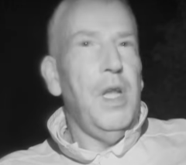

978.88 981.88 ANDY_BENNETT: I've been set for a minute. **To: cam**

981.88 983.88 ANDY_BENNETT One minute.

983.88 987.88 HOST They have spent their first night on the beach with no shelter.

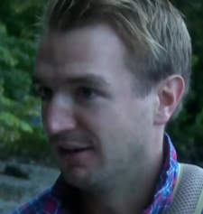

988.88 990.88 PIERS_28: That's not really shit.

990.88 992.88 VIC_47: Oh, what have we done? **To: cam**

995.88 1000.88 VIC_47: Did we get that realisation you've done something you didn't quite think all the way through?

1000.88 1003.88 VIC_47: At one point, I was shitting it, and we were going to get washed away.

1003.88 1005.88 VIC_47: I was like, did it get that close?

1005.88 1008.88 PIERS_28: You can see the line, mate. You can see the line. **To: cam**

1008.88 1010.88 PIERS_28: The line's what? Three foot away from everywhere? **To: cam**

1011.88 1013.88 PHIL_58: Look at that. **To: cam**

1013.88 1015.88 PHIL_58: A rubbish on this beach.

1015.88 1018.88 PIERS_28: Has anyone found a left shoe? **To: phil / all**

1018.88 1021.88 PAUL_36: Yeah, but these, I'm not too sure if I'm going to go for these.

1021.88 1023.88 PIERS_28: Oh, you! **To: paul**

1023.88 1024.88 PAUL_36: A bit last season. **To: all**

1024.88 1027.88 PIERS_28: Hey, lads, look. Found a pink pair.

1027.88 1028.88 PAUL_36: Yeah!

1028.88 1030.88 PIERS_28: These are bloody comfortable. **To: all**

1031.88 1033.88 PAUL_36: Look at these bad boys.

1033.88 1035.88 PAUL_36: This is the male version.

**Day time**

1035.88 1043.88 HOST The men came onto the island with just a day's supply of drinking water.

1043.88 1045.88 HOST No mouthfuls.

1045.88 1050.88 HOST But after yesterday's arduous trek in 34 degree heat, it's all but gone.

1050.88 1059.88 HOST Tropical storm season, really, there shouldn't be any shortage of water on the island, and obviously rain itself is drinkable without purification.

1059.88 1063.88 HOST But once it hits the ground, it becomes contaminated.

1063.88 1065.88 HOST All sorts of bacteria and nasties there.

1065.88 1070.88 HOST From experience, I can tell you, animals aren't fussy about where they crap.

1072.88 1073.88 DAN_29: Oh, my God. **To: cam**

1073.88 1077.88 DAN_29: Without a crap that's in there, it's fucking horrible.

1077.88 1083.88 HOST Without boiling, this rancid water would almost certainly give the men stomach cramps and diarrhea.

1083.88 1085.88 DAN_29 It's not salty, but...

1085.88 1088.88 JOE_22: I'll tell you what, I've had hungover shits that smelled better than that.

1088.88 1092.88 PIERS_28: Guys, can we... Why don't we all kind of gather in and have some sort of conflab? **To: all**

1092.88 1094.88 PIERS_28: about what were going to do today.

1094.88 1096.88 KYLE: Yeah, I think that might be a very good idea, please. **To: all**

1096.88 1097.88 VIC_47: Go on, guys, gather out.

1097.88 1098.88 PIERS_28: Like plan of action, that.

1098.88 1099.88 VIC_47: Yeah.

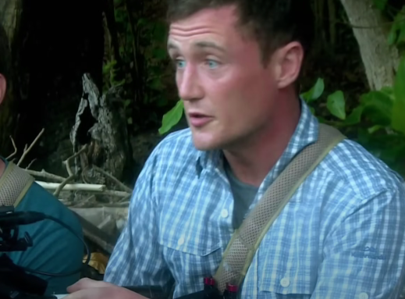

1099.88 1102.88 DAN_29: We 100% need to try and make a fire now.

1102.88 1109.88 SAM: If we don't make a fire and something to boil new water, we're going to be in bad shape by tomorrow morning. **To: all**

1109.88 1112.88 DAN_29: Food is becoming a priority very quickly for a lot of people. **To: all**

1112.88 1116.88 SAM: We're going to have to get something substantial to eat fairly soon.

1116.88 1117.88 SAM: Right, meeting adjourned. **To:all**

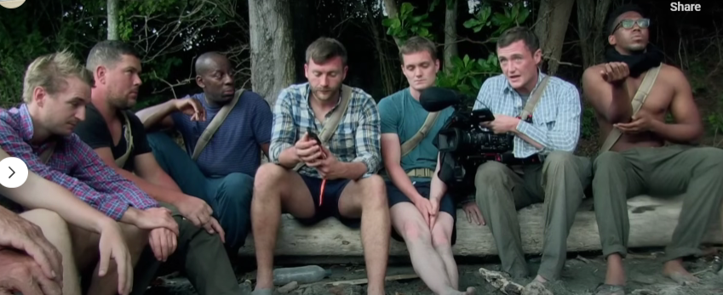

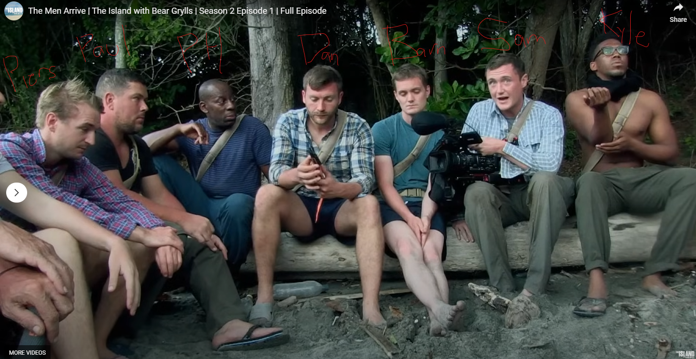

**piers, paul, phil, dan, barney, sam, kyle**

**<next scene>**

1119.88 1120.88 VIC_47: Shall we dance, sir?

1121.88 1122.88 VIC_47: Let's go.

1123.88 1125.88 HOST The men decide to split up.

1125.88 1135.88 HOST Having eaten nothing since they arrived, the majority of the group head off to look for food, while engineer Dan and builder Andy take on the fire lighting.

**Note: Dan and Andy stay behind**

1135.88 1138.88 DAN_29 It's quite a lot of pressure to get this fire going. **To: cam**

1138.88 1139.88 DAN_29: You're down?

1139.88 1140.88 ANDY: I'm up.

1140.88 1141.88 DAN_29 Yeah.

1141.88 1142.88 ANDY: Right.

1142.88 1143.88 DAN_29: To me.

1143.88 1144.88 ANDY: Awesome.

1144.88 1146.88 DAN_29: That is not an ideal start, is it? **To: andy**

1146.88 1147.88 DAN_29: That it was drunk.

1147.88 1149.88 DAN_29: Oh, lads.

1149.88 1150.88 ANDY_BENNETT: I shot my load. **To: cam**

1152.88 1157.88 VIC_47: Around about here, there's about six, maybe ten snails and shit, yeah?

1157.88 1164.88 HOST Along the coast, 47-year-old Vic has decided to put Joe, the group's youngest member, to work. **To: vic -> joe**

1164.88 1166.88 JOE: We should definitely have put some fucking shoes on.

1166.88 1168.88 VIC_47: That might have been a wise idea, fella.

1168.88 1169.88 JOE: Oh!

1169.88 1172.88 VIC_47: Just anything, Olympics, crabs, give them a crack.

1172.88 1175.88 VIC_47: Snails, you spot them, fella, and I'll club them.

1175.88 1177.88 VIC_47: Do these snails bite? **To: cam**

1177.88 1180.88 VIC_47: I feel something with legs is going to come out of there, isn't it? **To: cam**

1180.88 1181.88 VIC_47: Nip it.

1181.88 1185.88 VIC_47: Don't put your finger where you want to put your dick, because it might get bitched. **To: joe**

1185.88 1190.88 CHARLIE: And this, ladies and gentlemen, is how the nearest we get to Michelin's star.

1190.88 1192.88 CHARLIE: Will we put it on a bed of anything?

1198.88 1199.88 HOST One.

1200.88 1204.88 HOST A morning's hard graft provides nothing more than a handful of limpets.

1204.88 1205.88 HOST Yeah.

1208.88 1209.88 None Come on.

1214.88 1215.88 KYLE: Give it a good old cheer. **To: andy**

1215.88 1216.88 ANDY: Fucking hell! **To: ?**

1216.88 1218.88 SPEAKER_10 Yeah. Yeah, it's up.

1219.88 1220.88 BARNEY: Limpets.

1220.88 1221.88 BARNEY: Aw.

1221.88 1223.88 BARNEY: Horrendous.

1223.88 1225.88 FARMAR: You don't buy them in supermarkets, do you?

1225.88 1227.88 FARMAR: So they're not known for being very nice.

1227.88 1229.88 FARMAR: I don't think they're very nice at all.

1231.88 1233.88 HOST For now, the men will have to go hungry.

1234.88 1235.88 ANDY_BENNETT Stop. **To: dan**

1236.88 1238.88 ANDY_BENNETT: Who said there's no smoke without fire? **To: dan**

1238.88 1239.88 DAN: Lying bastards. **To: Andy**

1239.88 1241.88 PIERS: Fates spits me off a little bit.

1242.88 1244.88 DAN: I just don't know what we're doing wrong. **To: cam**

1245.88 1249.88 HOST Lighting a fire has become an urgent priority.

1249.88 1255.88 HOST It's 34 degrees in the shade, and the men have had little to drink in the past 12 hours.

1255.88 1258.88 HOST We've literally... we've got no water. **To: Cam**

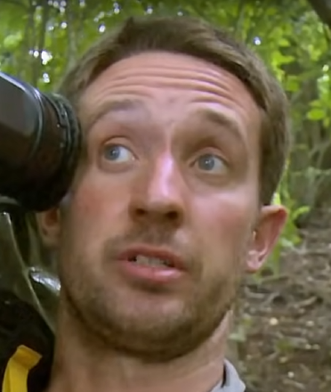

1258.88 1259.88 WILL: None at all.

1259.88 1260.88 VIC_47: None.

1260.88 1261.88 VIC_47: They had a piss.

1261.88 1264.88 VIC_47: 20 minutes ago, they were like pissing the lions golden syrup.

1264.88 1266.88 VIC_47: I had to push it out.

1271.88 1273.88 SPEAKER_00 That is not viscous and clear. **To: cam**

1273.88 1274.88 SPEAKER_00 No, it's definitely not.

1274.88 1279.88 HOST The men are starting to show the telltale signs of serious dehydration.

1279.88 1280.88 ANDY Thirsty.

1280.88 1282.88 ANDY Really bloody thirsty.

1283.88 1284.88 ANDY You got out, innit?

1284.88 1285.88 DAN Fuck off.

1286.88 1289.88 VIC_47: The vultures are circling already. **To: all**

1289.88 1291.88 VIC_47: Can you look at the size of that?

1291.88 1292.88 SPEAKER_07 Jesus.

1292.88 1293.88 VIC_47L That's prehistoric.

1294.88 1295.88 KYLE: How about your glasses? **To: andy**

1295.88 1296.88 KYLE: Do you reckon we can...

1296.88 1297.88 KYLE: Can I try your glasses?

1297.88 1298.88 ANDY : Try it, mate. **To: kyle**

1298.88 1299.88 KYLE: Yeah.

1299.88 1301.88 HOST: With their need for fire now critical,

1301.88 1304.88 HOST: web consultant KYLE: has an idea he wants to try.

1305.88 1309.88 HOST He's got a lot of air in his mouth. He's got a lot of air in his mouth.

1309.88 1312.88 HOST And KYLE: has an idea he wants to try.

1312.88 1314.88 KYLE: We've got Andy's glasses. **Kyle and andy work together**

1314.88 1317.88 KYLE: Just basically using the sun to focus on one point.

1317.88 1319.88 KYLE: It's given us quite a lot of heat.

1319.88 1320.88 None Come on.

1321.88 1322.88 KYLE: I'm on.

1323.88 1326.88 CHARLIE: I don't think that's gonna work, the old glasses.

1329.88 1330.88 ANDY_BENNETT: Let go, let go.

1333.88 1335.88 SPEAKER_07 Oh, go on, Andy lad. **To:**

1335.88 1336.88 SPEAKER_07 Sticks, huh?

1336.88 1337.88 SPEAKER_07 Yeah, the little sticks.

1337.88 1338.88 SPEAKER_07 Preparation.

1338.88 1339.88 SPEAKER_07 Where's the next light stick?

1339.88 1340.88 SPEAKER_07 Where's the next light stick?

1340.88 1341.88 SPEAKER_16 Fucking sticks.

1342.88 1344.88 SPEAKER_16 Get up there, get up there.

1346.88 1347.88 PIERS: No, right.

1347.88 1348.88 PIERS: Put it off, put it off.

1348.88 1349.88 PIERS: Real tight.

1349.88 1350.88 PIERS: Breathe it.

1350.88 1351.88 PIERS: Go on, Andy.

1351.88 1352.88 DAN: Go on, so.

1352.88 1353.88 DAN: Hold on.

1353.88 1354.88 DAN: Just go hard.

1354.88 1355.88 KYLE: Go hard, you'll go.

1355.88 1356.88 KYLE: Come on.

1356.88 1357.88 PIERS: You're only a bit close.

1357.88 1358.88 PIERS: That's it.

1358.88 1359.88 DAN: Come on, it's nearly there.

1359.88 1360.88 VIC: Keep going.

1360.88 1361.88 VIC: Keep going, keep going.

1361.88 1362.88 VIC: You got it, you got it, you got it.

1362.88 1363.88 VIC: You got it, you got it.

1363.88 1364.88 VIC: You got it, you got it.

1364.88 1365.88 VIC: You got it.

1365.88 1366.88 VIC: You got it.

1367.88 1368.88 SPEAKER_16 Yes!

1368.88 1369.88 SPEAKER_16 Yes!

1369.88 1370.88 SPEAKER_16 You got it.

1370.88 1371.88 SPEAKER_16 The little tweaks.

1371.88 1372.88 SPEAKER_16 Yeah.

1372.88 1373.88 SPEAKER_16 The end of you.

1373.88 1374.88 SPEAKER_16 All right, go.

1374.88 1375.88 SPEAKER_16 All right.

<everyone celebrates> <fire achieved>

**Note: Andy and Kyle dancing together**

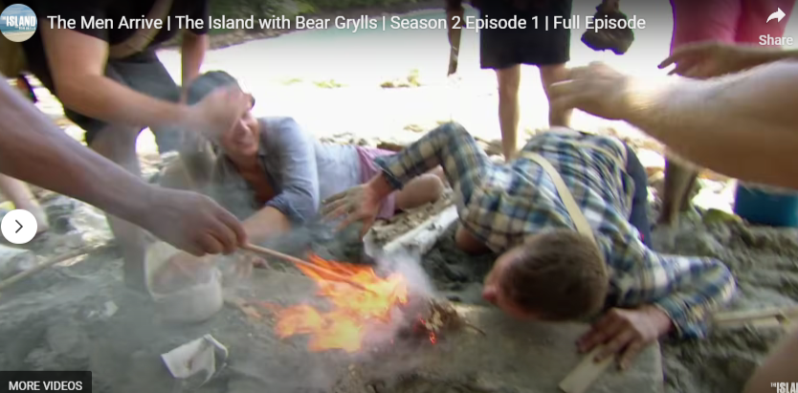

1377.88 1378.88 SPEAKER_16 Yeah, there you go.

1379.88 1381.88 VIC_47: Bingo, well done you two.

1381.88 1382.88 ANDY: It was KYLE: that started it.

1382.88 1384.88 VIC_47: Of course, of course it was.

1384.88 1386.88 **VIC_47**: He showed me the way and I followed through.

1386.88 1387.88 **KYLE**: I see, we've done well.

**Note: Kyle and Vic are shaking hands**

1387.88 1388.88 VIC_47: We got there.

1388.88 1389.88 VIC_47: Absolutely brilliant.

1389.88 1390.88 VIC_47: Well done.

1390.88 1391.88 VIC_47: What a dark horse, steals the pole.

1391.88 1394.88 VIC_47: We take it back about the IT guy.

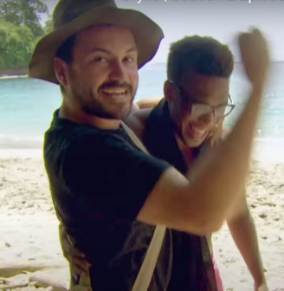

**ROSS AND KYLE ARE HUGGING**

1394.88 1395.88 SPEAKER_01 Yes!

1395.88 1396.88 JOE: Well done, KYLE:. **To: kyle**

1396.88 1408.00 HOST After eight hours of trying, the men finally have a fire on which to boil the stagnant water.

1408.00 1412.24 VIC_47: I'm going to drink and drink and drink until my piss falls clear. **To: cam**

1412.24 1413.24 VIC_47: And your birdie kiss.

**<all drinking clean water together>**

1413.24 1414.24 VIC_47: It's almost like normal water.

1414.24 1417.24 SPEAKER_10 There's a bit of sort of pond in there.

1417.24 1419.12 SPEAKER_17 That is top notch.

1419.12 1422.84 SPEAKER_17 It doesn't taste like piss, does it?

1422.84 1423.84 ANDY: It's like mile way tea.

1424.72 1429.64 HOST As long as the fire stays lit, the men will have a source of safe drinking water.

1429.64 1431.64 KYLE: It's tough to that.

1431.64 1432.64 KYLE: It's tough to that.

1432.64 1434.64 DAN: What an achievement, yeah? **To: cam**

1434.64 1439.64 HOST But keeping it alight during tropical storm season will be a huge challenge.

1439.64 1442.64 HOST Shit, look at that rain.

1442.64 1445.64 SAM: So look like right there, tropical paradise.

1445.64 1447.64 SAM: And then...

1447.64 1448.64 PAUL_36: There.

1448.64 1449.64 PAUL_36: Shit hole.

1449.64 1450.64 PAUL_36: Shit hole.

1450.64 1453.64 PAUL_36: And it's like weight shows in Aldi all in one picture.

1456.64 1462.64 PAUL_36: What I'm worried about is everyone's off doing other things and in a minute it's going to be pissing down with rain. **To: ALL**

1462.64 1466.64 PAUL_36: I actually think it would be quite important to build a shelter for the fire.

1466.64 1470.64 ANDY_BENNETT: I've not got the energy to build a shelter or anything at the moment. **To: ALL**

1470.64 1471.64 ANDY_BENNETT: If I could, I would.

1471.64 1472.64 ANDY_BENNETT: I promise you.

1473.64 1475.64 PAUL_36: A little bit worried about Andy.

1475.64 1479.64 PAUL_36: He seems to have separated himself from the group a little bit. **To: CAM(SELF VLOG)**

1479.64 1485.64 PAUL_36: When everybody's together hes walked off, he's now making a bed over there, which just seems a bit childish.

**Note: PAUL IS NOT HAPPY WITH ANDY, THINKS HE DOESN’T WANT TO BE PART OF THE GROUP**

1485.64 1488.64 PAUL_36: Feels like he doesn't want to be part of the group.

1488.64 1489.64 ANDY_BENNETT: Hey, hey, I've got a bed.

1489.64 1492.64 ANDY_BENNETT: All I want to do at the moment is get some sleep.

1492.64 1494.64 ANDY_BENNETT: Just some, you know?

1498.64 1500.64 ANDY_BENNETT: I think middle age has made me boring. **To: CAMERA**

1500.64 1503.64 ANDY_BENNETT: I've got a beautiful wife, lovely house, nice job, etc.

1503.64 1506.64 ANDY_BENNETT: All the stuff that most people strive to get.

1506.64 1508.64 ANDY_BENNETT: And yet I'm still searching for something.

1508.64 1510.64 ANDY_BENNETT: Perhaps all men get like that.

1510.64 1511.64 ANDY_BENNETT: I don't know.

1511.64 1512.64 ANDY_BENNETT: Perhaps I'm at a midlife crisis.

1512.64 1514.64 ANDY_BENNETT: I don't like myself as much as I used to.

1514.64 1516.64 ANDY_BENNETT: Put it that way.

1516.64 1520.64 ANDY_BENNETT: I think I need a new adventure to put that right.

**Note: Lying down relaxing**

1534.64 1536.64 PAUL: Do you want help us get a sanctum to cover this up? **To: CAM**

1537.64 1538.64 PAUL: Cause its going out already (the fire).

1538.64 1540.64 HOST An hour before sunset.

1540.64 1543.64 CHARLIE: The heavens have opened, as expected. **To: CAM**

1543.64 1545.64 PAUL_36: We've got a fire going.

1545.64 1546.64 PAUL_36: Yeah, but we've got to put it in.

1546.64 1548.64 PAUL_36: However it is now pissing down with rain.

1548.64 1551.64 PAUL_36: We've got no cover over it whatsoever. **To: ALL**

1551.64 1554.64 PAUL_36: We've got nowhere to sleep whatsoever. **To: ALL**

1554.64 1559.64 PAUL_36: So I would say our priority is shelter. **To: ALL**

1559.64 1564.64 PAUL_36: Honestly, in the politest way of course, we need to cover up this fucking fire because it's going to go out. **To: ALL**

1564.64 1568.64 HOST Without the fire, the men will have no means of purifying water to drink.

1568.64 1569.64 PHIL: Who was doing the leaves? **To: ALL**

1569.64 1571.64 PHIL: Is anybody getting the leaves to cover this? **To: ALL**

1571.64 1575.64 PAUL: That is going out in about half an hour. **To: ALL**

1575.64 1577.64 CHARLIE: Ah, clusterfuck or poo bar. **To: CAM**

1577.64 1579.64 CHARLIE: I don't know what the correct military term is.

1579.64 1582.64 CHARLIE: So now we've got a million people trying to do a million things.

1582.64 1584.64 CHARLIE: Hopefully we'll have a million answers.

1584.64 1586.64 PAUL_36: So I'm just fucking mad. **To: SELF**

1587.64 1589.64 BARNEY: This rain is absolutely unbelievable. **To: ALL**

1589.64 1591.64 None You don't ever see rain like this.

1591.64 1592.64 None It's OK.

1592.64 1595.64 SPEAKER_09 Absolutely, completely stoking.

1595.64 1600.64 HOST: 8pm, the men are still desperately trying to make a watertight shelter to save their fire.

1600.64 1602.64 SPEAKER_09 Open under, that's it.

1602.64 1604.64 HOST See if we can bend it, Bart.

1604.64 1607.64 HOST In this part of the Pacific, storms can last for a while.

1607.64 1609.64 HOST But we've got to get out of here.

1609.64 1611.64 PHIL_58: We've got to get out of here.

1611.64 1613.64 PHIL_58: See if we can bend it, Bart.

1613.64 1620.64 HOST In this part of the Pacific, storms can last for days and dump inches of rain in an hour.

1621.64 1622.64 PAUL_36: It's a great night. **To: CAM**

1622.64 1625.64 PAUL_36: Obviously we're staying dry under the shelter that we've made.

1625.64 1629.64 PAUL_36: It's a good job we made it, otherwise we'd be absolutely saturated right now. **To: CAM**

1629.64 1633.64 PAUL_36: The roof might need possibly a tweak or two.**To: CAM**

1633.64 1638.64 PAUL_36: There is a minor bit of snagging before practical completion. **To: CAM**

1638.64 1643.64 PAUL_36: It's just something simple, like perhaps taking the whole fucking thing down and redoing it. **To: CAM, Note: ALL LAUGH**

1647.64 1649.64 PAUL_36: Has anyone checked on Andy? **CONCERNED FOR ANDY**

1650.64 1651.64 PAUL_36: Oh, for God's sake.

1651.64 1652.64 SPEAKER_01 Andy!

1652.64 1654.64 SPEAKER_01 Andy!

1654.64 1656.64 SPEAKER_01 Andy!

1656.64 1658.64 SPEAKER_01 We've got a headlight going for us.

1658.64 1665.64 PAUL_36: Andy chose to not help the group in any way, shape or form and went off on his own.   
**Note: PAUL MAD WITH ANDY AGAIN, SAYING HE IS NOT HELPING THE GROUP, rallying the others against him?**

1665.64 1666.64 PAUL_36: Andy's here.

1666.64 1668.64 PAUL_36: Vick, Andy's here under the tree.

1668.64 1672.64 PAUL_36: I think Andy needs to get a little bit more involved with this, to be honest.

1677.64 1680.64 DAN: It absolutely pissed down last night. **To: CAM**

1680.64 1684.64 DAN: Everyone was away and everyone was just so wet through.

1685.64 1688.64 DAN: I was sat there and I was just thinking, what am I doing here? **To: CAM**

1688.64 1690.64 DAN: I feel kind of pissed. **To: ALL / KYLE**

1690.64 1691.64 KYLE: Yeah. **To: DAN**

1691.64 1692.64 DAN: It's weird.

1692.64 1695.64 DAN: I feel like I've had a couple of pints. **To: ALL / KYLE**

1695.64 1697.64 PAUL_36: I can't move my legs. **To: DAN**

1697.64 1699.64 PAUL_36: I've sat up, I just can't move.

1699.64 1700.64 DAN: It's the bed parallel. **To: PAUL**

1700.64 1701.64 PAUL_36: Yeah.

1701.64 1702.64 PAUL_36: That's great.

1702.64 1704.64 PAUL_36: Completely numb from cock down.

1705.64 1707.64 HOST 6am.

1707.64 1711.64 HOST Last night a violent tropical storm battered the island.

1712.64 1718.64 HOST After a desperate struggle, the group managed to save their fire with a small temporary shelter.

1718.64 1722.64 HOST But the men themselves had no protection from the elements.

1723.64 1725.64 ANDY_BENNETT: Video diary. **To: SELF**

1725.64 1728.64 ANDY_BENNETT: I don't know what day it is. I don't know if it's day two, day three.

1728.64 1731.64 ANDY_BENNETT: Still no sleep after getting on the island.

1731.64 1735.64 ANDY_BENNETT: I think I've had about, honestly, swear to God, an hour of sleep.

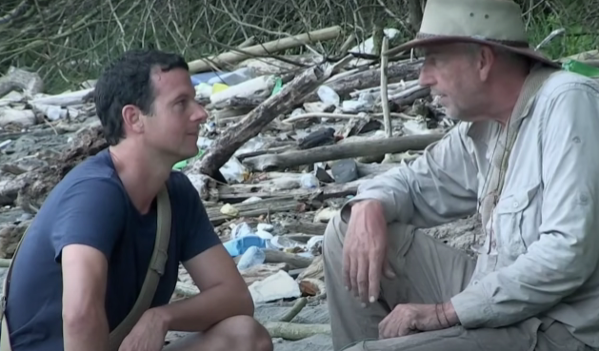

1735.64 1737.64 ANDY_BENNETT: I can't do it. **To: WILL**

1738.64 1741.64 ANDY_BENNETT: I've got to think about myself now, you know?

1741.64 1742.64 ANDY_BENNETT: Yeah.

1742.64 1743.64 ANDY_BENNETT: I've been up all fucking night.

1743.64 1744.64 ANDY_BENNETT: I'm a mess because of it.

1744.64 1749.64 HOST Sleep really is critical to survival because it affects our physical and our mental health.

1750.64 1754.64 HOST When you get enough of it, it helps your body to recover, to heal.

1754.64 1759.64 HOST You process thoughts, process memories, but when you don't get enough of it, that's when you become careless.

1759.64 1763.64 HOST It affects your decision-making abilities and it can even lead to depression.

1766.64 1767.64 WILL: You all right, fella? **To: JOE**

1767.64 1768.64 WILL: Mm.

1768.64 1769.64 WILL: What's up?

1770.64 1775.64 JOE: I was struggling a bit, I think, at the moment. **To: WILL**

1775.64 1776.64 WILL: With?

1776.64 1779.64 JOE: The mentality of it all. You know what I mean?

1779.64 1781.64 JOE: You've got to get yourself in my care.

1784.64 1785.64 JOE: In the zone, is it, where?

1785.64 1787.64 JOE: I'm struggling to find the zone.

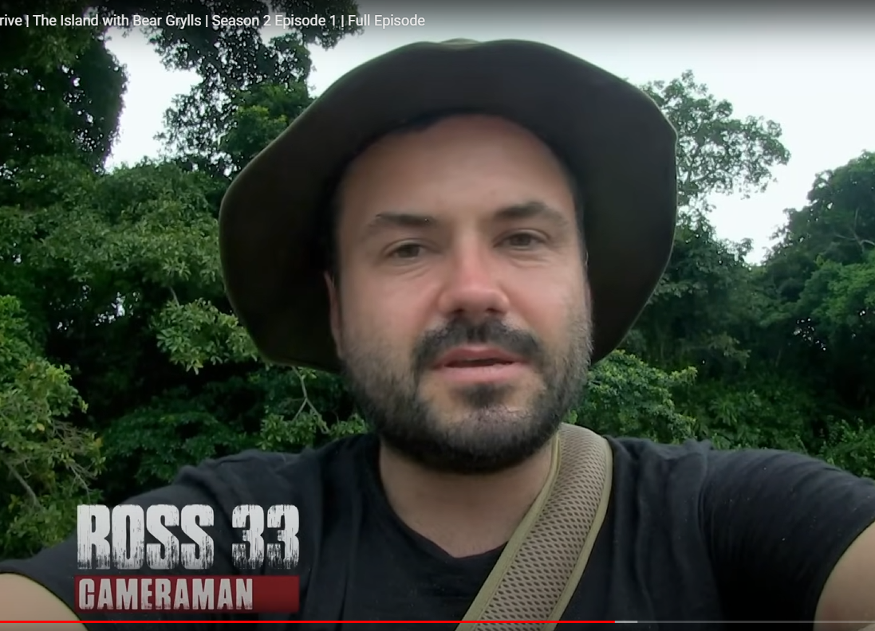

1789.64 1791.64 ROSS: I'm really worried about Joe. **TO:**

1791.64 1796.64 ROSS: He's just kind of wandering around, sitting down, hitting his hands.

1796.64 1799.64 ROSS: Kind of looks like he's feeling sorry for himself, will he?

1799.64 1801.64 ROSS: And he's obviously missing home.

1801.64 1802.64 FARMAR: What's her name?

1802.64 1803.64 JOE: Charlotte.

1804.64 1806.64 FARMAR: You miss her, mate, don't you?

1810.64 1811.64 JOE: Yeah.

1812.64 1813.64 JOE_22: Best thing that happened to me, huh? **TO: WILL**

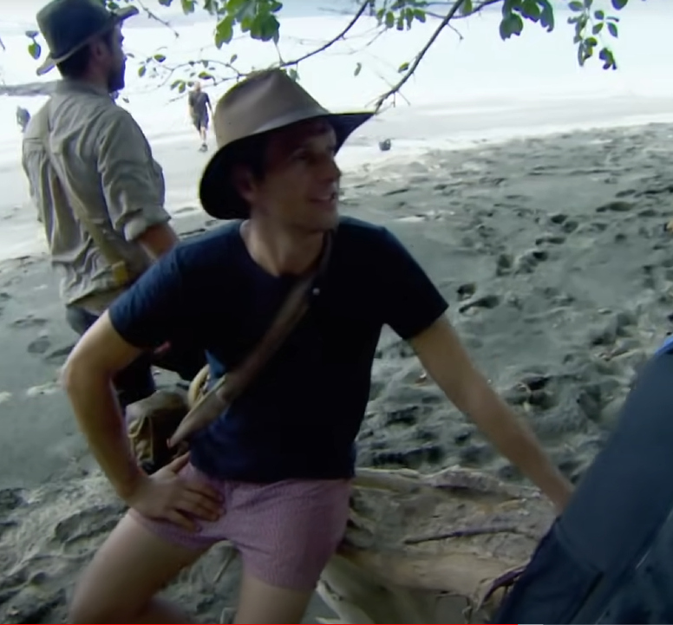

1813.64 1815.64 JOE_22: How long have you been together?

1815.64 1816.64 JOE_22: Five years.

1816.64 1820.64 JOE_22: It's been the first time ever, because I've met her, that I've gone 24 hours without speaking to her, so...

1823.64 1824.64 BARNEY: Come on, dude, hug it out.

1827.64 1828.64 BARNEY: You'll be fine, mate. You'll be fine.

1828.64 1829.64 BARNEY: We'll be fine. We'll be fine.

1829.64 1830.64 BARNEY: We'll be fine.

1830.64 1831.64 BARNEY: We'll be fine.

**Note: BARNEY AND JOE HUG**

1834.64 1841.64 CHARLIE_32: If I don't have a good night's sleep fairly soon, I'm going to end up throttling someone inadvertently.

1841.64 1843.64 CHARLIE_32: I'm not joking. I'll lose my rag. **To group**

1843.64 1846.64 PAUL_36: I want a bed to sleep in, and I'm not going to get something wet. **To group**

1849.64 1855.64 HOST The group are relying on their two builders, Andy and Paul, to construct a new watertight shelter.

1855.64 1859.64 HOST But both have a very different idea about where to put it.

**Note:** **PAUL AND ANDY HAVE DIFFERING OPINIONS ON HOW TO BUILD THE SHELTER**

1859.64 1862.64 CHARLIE: We need to pick a location to build this shelter on.

1862.64 1863.64 CHARLIE: Put it.

1863.64 1865.64 CHARLIE: We have two potential locations.

1865.64 1867.64 CHARLIE: Andy, is your place on the beach? **TO: ANDY**

1867.64 1868.64 ANDY: Yeah.

1870.64 1873.64 ANDY_BENNETT: I think these little bits of thicket brush easily.

1873.64 1874.64 CHARLIE: Yeah.

1874.64 1876.64 ANDY_BENNETT: Look, we've got a pit there for a fire pit. **TO: DAN**

1876.64 1878.64 ANDY_BENNETT: This is absolutely perfect camp.

1878.64 1879.64 ANDY_BENNETT: Job's good.

1880.64 1881.64 ANDY_BENNETT: This is not Andy's, is it?

1883.64 1889.64 SAM: You're more exposed to the tide. You're more exposed to the weather, and we're going to get beaten to smotherings by sandplugs.

1889.64 1890.64 PAUL_36: It's not an option.

1890.64 1891.64 PAUL_36: No way.

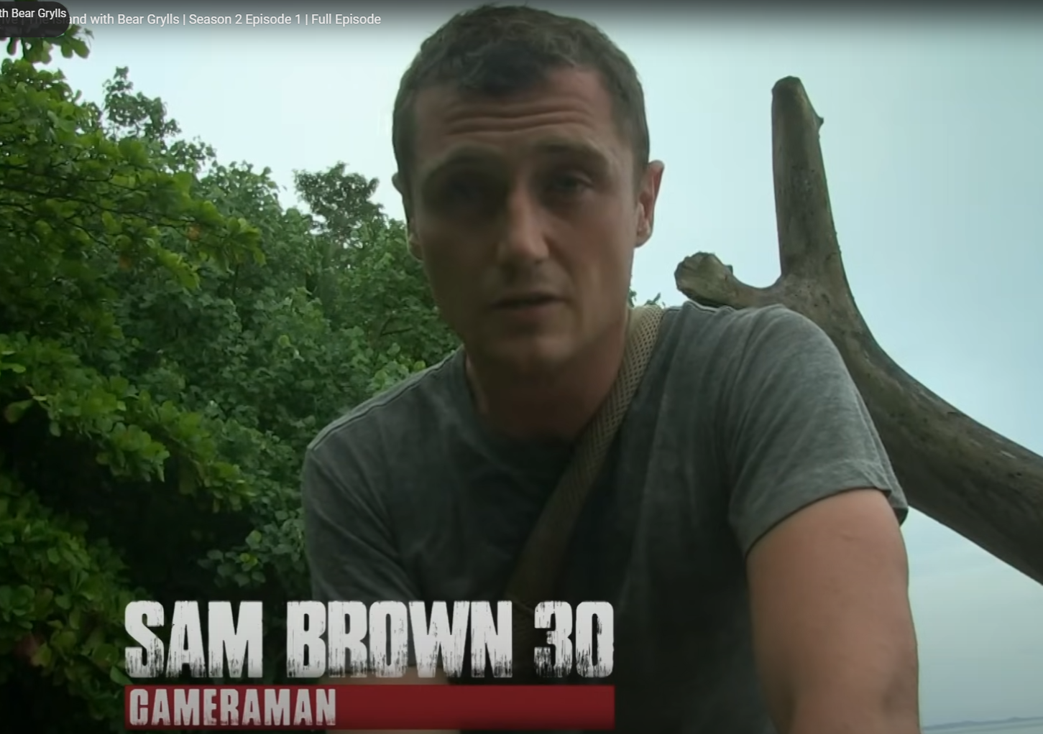

1891.64 1894.64 SAM: Andy's camp, it looks like it'll flood at the tidal surge.

1894.64 1897.64 SAM: There's plastic bottles everywhere. I think we'll get bitten to shit.

**Note: SAM DOES NOT LIKE ANDY’S SHELTER AND DOES NOT TRUST IT**

1898.64 1900.64 ANDY: Pointless. Give me my opinion, mate.

1903.64 1905.64 ANDY_BENNETT: Fuckin' nobody listened to fuckin' me.

1906.64 1910.64 PAUL_36: I would love to have come down here for Andy's sake and gone, this is fucking brilliant, mate.

1910.64 1915.64 PAUL_36: The trouble is, we walked in here, and I kept my mouth shut, but within 30 seconds, everyone went, are you fucking joking?

**Note: PAUL AND ANDY BEEFING**

1916.64 1918.64 ANDY_BENNETT: I'm a builder. People get me in to fix anything.

1918.64 1920.64 ANDY_BENNETT: Customers phone me up to put their Ikea.

1920.64 1923.64 ANDY_BENNETT: Bedroom stuff together. It's like, what, fuck you then? **TO: CAM**

1924.64 1928.64 HOST: With Andy's sight rejected, Paul shows the men his preferred location.

1929.64 1933.64 PAUL_36: Because it's elevated, this is not really going to get that wet. **TO:DAN**

1933.64 1937.64 CHARLIE: It's got a fairly good canopy. We can all sleep here on the dry.

**PAUL AND CHARLIE AGREE WITH THE SAME LOCATION AND LIKE IT**

**DAN LIKES THE LOCATION**

1937.64 1939.64 PAUL_36: Correct. You've got a nice little breeze coming through as well.

1939.64 1940.64 DAN: Yeah, I like this place.

1943.64 1946.64 PAUL_36: Well, what we need now is cross members.

1947.64 1959.64 SAM: I'm a bit surprised about Paul being a volcanic rhinoceros, but you know what? He's single-minded, but he makes clear decisions and sticks by them, and he's been right more than he's been wrong so far.

**Note: SAM is unsure about paul, not a huge fan, but hes been right most of the time**

**VID ASKS PAUL FOR ADVICE, AND PAUL RESPONDS**

1960.64 1964.64 PAUL_36: Ah! We're fucking saved. We're a bit all right now.

1965.64 1967.64 PAUL_36: Knew there was power on the island.

1971.64 1974.64 VIC_47: I find it a bit shocked at how difficult… **TO:JOE**

1974.64 1976.64 VIC_47: How difficult it's been. **TO: JOE**

1976.64 1978.64 VIC_47: We're all here doing the same shit.

1978.64 1981.64 VIC_47: We're all not sure whether we're shitting. See you at bush.

1981.64 1989.64 HOST Determined to boost Joe's morale and keep his mind off home, Father of Three Vic has asked him to join in with the shelter build.

1990.64 1992.64 VIC: It's a challenge. A fucking challenge. **TO:JOE**

**VIC IS TRYING TO BE A MENTOR TO JOE**

1992.64 1994.64 VIC_47: Youll adapt to all this quicker than any of us will.

1994.64 1995.64 VIC_47: Far quicker.

1996.64 2001.64 VIC_47: It's a case of making sure everybody guides everybody else in the right direction.

2001.64 2009.64 VIC_47: I do firmly believe we will become an excellent team to the point of becoming almost like a tribe.

**VIC HELPING JOE**

2013.64 2022.64 JOE_22: What do you say? Building camp, the top of a steep hill, in the middle of rainy season, is the stupidest idea ever had?

2024.64 2026.64 JOE_22: A chain is only as strong as its weakest link.

2026.64 2028.64 JOE_22: I'm obviously the weakest link.

2028.64 2030.64 PIERS: Joe, you're not the weakest link. You're just missing home.

2030.64 2032.64 PIERS: It's a natural thing to feel.

2032.64 2034.64 JOE_22: I think some people do think I'm the weakest link.

2034.64 2036.64 JOE_22: I don't think so.

2036.64 2038.64 JOE_22: No, but I think you do. **TO: VIC**

**JOE THINKS VIC LOOKS DOWN ON HIM**

**JOE THINKS HE IS THE WEAKEST LINK AND EVERYONE THINKS SO**

2038.64 2040.64 VIC_47: Do you think so, Crikey, what's made you think that?

2040.64 2043.64 JOE_22: Day one, I've been shouting orders at me from day dark.

2043.64 2047.64 JOE_22: We're carrying stuff in and out of a jungle and I've got a heavy rucksack on my back.

2047.64 2049.64 JOE_22: Joe, I think it's a good idea if you do this.

2049.64 2056.64 JOE_22: You've not been shouting orders at anyone else, but I think you feel I'm the youngest, therefore naturally you've got some authority over me. **TO: VIC**

**JOE THINKS ADVICE IS GIVEN TO HIM BECAUSE HE IS SEEN AS THE WEAKEST BY OTHERS (VIC)**

2056.64 2058.64 JOE_22: That's been grinding on me a little bit.

2058.64 2066.64 VIC_47: Joe intimated that I'd been giving him a hard time, which I truly have only tried to be positive with everybody. **TO: SELF**

**VIC HAD NO BAD INTENTIONS, AND IS SAD ABOUT HOW JOE FEELS**

2066.64 2068.64 VIC_47: I would devastate you.

2068.64 2073.64 VIC_47: You've been aggressive. You're being passive-aggressive, and that's not fair. All right?

2073.64 2075.64 VIC_47: He just told me I'm being passive-aggressive.

2075.64 2077.64 JOE_22: Okay, yeah, you didn't.

2087.64 2092.64 HOST However bad your situation is, you can't wallow in negativity.

2092.64 2098.64 HOST Survival is about dogged determination, learning from your failures, and never giving up.

2098.64 2100.64 HOST And Churchill once said a great quote.

2100.64 2104.64 HOST He said, if you're going through hell, keep going.

2105.64 2108.64 JOE_22: The balls are doing the backstroke and a bucket of sand. **TO:SELF**

2108.64 2111.64 JOE_22: I'm hungry. I'm tired.

2111.64 2116.64 JOE_22: All that's going through me head is, I don't sell farm at home, so why the hell am I selling farm here?

2118.64 2120.64 JOE_22: 6am.

**BRITISH LINGO GOING CRAZY**

2121.64 2130.64 PHIL_58: I've never been in an environment where last night you hear a thunderstorm, and it's now daylight, and it's still thundering, and it's still raining. **TO: CAM**

2130.64 2134.64 HOST Overnight, torrential rain has once again battered the island.

2134.64 2139.64 HOST The men have managed to protect the fire, but their spirits are low.

2140.64 2143.64 PHIL_58: It is a bit mind-boggling that you can have this much rain. **TO: CAM**

2143.64 2146.64 PHIL_58: It's so long, it just keeps coming.

2146.64 2150.64 HOST Yesterday, the men started work on a new shelter.

2150.64 2154.64 HOST But only half-built, it was no match for the elements.

2155.64 2158.64 SPEAKER_18 I'm massively under-esting all of this place, massively.

2158.64 2162.64 SPEAKER_18 I'm so fussed in, and I've been too young to remember.

2162.64 2165.64 SPEAKER_18 That's dope, when I got my first hunger rumble.

2165.64 2168.64 SPEAKER_18 It seems playing on my mind a lot more.

2168.64 2170.64 SPEAKER_18 It's hard. **TO: SELF**

2173.64 2176.64 ROSS: This is apocalyptic weather. **TO:SELF**

2176.64 2179.64 ROSS: They're threatening to wash us out of this camp.

2179.64 2184.64 HOST For the third night in a row, the men have barely slept.

2184.64 2187.64 PHIL: The positive? It's daytime. **TO:SELF**

2187.64 2189.64 PHIL: I can see how crap it is.

2192.64 2194.64 HOST: Here in the tropics, when it rains...

2194.64 2196.64 HOST It's not just nice British drizzle.

2196.64 2199.64 HOST It's torrential. We can hardly hold a conversation.

2199.64 2207.64 HOST You've got to spend so much time and energy trying to keep your fire alight when you could be out there fishing or hunting or making shelters, however strong and determined.

2207.64 2210.64 HOST After a while, it saps you.

2210.64 2214.64 HOST It saps your spirit in the same way it saps a life out of a fire.

2214.64 2217.64 ANDY_BENNETT I cannot face another day on here. **TO:SELF**

2217.64 2219.64 ANDY_BENNETT Honestly, I can't.

2219.64 2223.64 ANDY_BENNETT: I'm at the stage of almost a breakdown, to be totally honest.

2223.64 2226.64 ANDY_BENNETT: You just can't imagine how tough it is.

2226.64 2228.64 ANDY_BENNETT: Unbelievable.

2235.64 2238.64 HOST The island's youngest member, Joe, says he's had enough.

**JOE DECIDING TO LEAVING**

2241.64 2243.64 JOE_22: Four weeks, and it would be a push for me.

2243.64 2245.64 JOE_22: Six weeks, I didn't think I'd ever make it.

2245.64 2250.64 JOE_22: The pain I'm going to go through here, leaving the loved ones at home, the charlotte, all the rest of it. **TO: PIERS**

2250.64 2252.64 PIERS: Then why did you sign up?

2252.64 2254.64 JOE_22: I don't know.

**PIERS QUESTIONS PIERS DECISIONS ON SIGNING UP**

2259.64 2262.64 HOST 10am. The storm finally passes.

2264.64 2273.64 HOST Determined to leave as soon as possible, graphic designer Joe uses the emergency satellite radio to request an evacuation boat.

2274.64 2284.64 JOE_22: I just really strongly believe that as a person, physically, mentally and all the rest of it, I am not going to make the rest of the time on the island.

2284.64 2292.64 JOE_22: I've not made any rash decisions, because I'm aware that you can make decisions in the heat of a moment, and I haven't had this really fancy and margarita pizza.

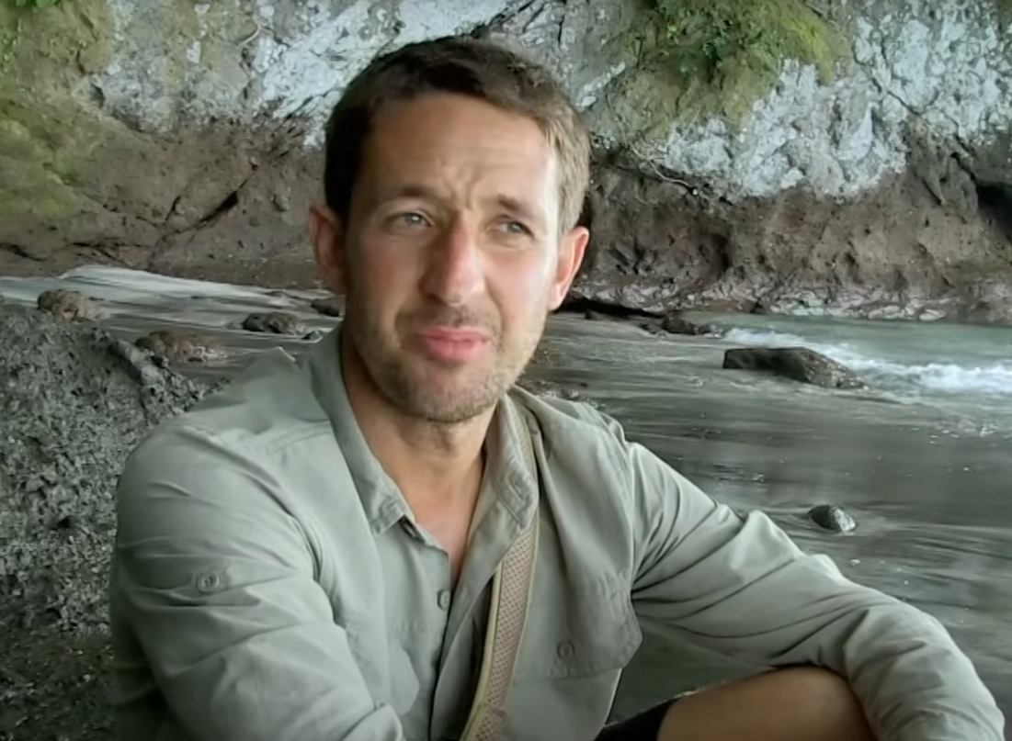

**NEGATIVE ABOUT JOE LEAVING**

2293.64 2295.64 WILL: Joe wants to go home.

2295.64 2297.64 WILL: I can't believe it.

2297.64 2300.64 WILL: He's not been here four days. He's not even started.

2300.64 2302.64 WILL: He wants to go home.

2302.64 2310.64 HOST Joe has agreed to stay on the island for another 24 hours before making a final decision about whether he wants to leave.

2311.64 2312.64 VIC_47: You got it up there, Mark?

2312.64 2313.64 VIC_47: Get him a couple.

2313.64 2315.64 VIC_47: Is it long enough?

2315.64 2316.64 VIC_47: No.

2316.64 2318.64 VIC_47: You can go halfway there.

2318.64 2321.64 HOST In the jungle, work continues on the shelter.

2321.64 2324.64 PAUL_36: Can you get that any higher?

2324.64 2330.64 HOST The group have persuaded Andy to help out, hoping the prospect of a dry night will encourage him to stay.

**PAUL AND ANDY ARE WORKING ON CONSTRUCTION TOGETHER**

2330.64 2331.64 ANDY One there.

2331.64 2332.64 PAUL_36 Yeah.

2332.64 2333.64 ANDY And one down here.

2333.64 2334.64 PAUL_36: So not there then?

2334.64 2335.64 ANDY : Eh?

2335.64 2336.64 PAUL_36: So not there then.

2336.64 2337.64 ANDY: I didn't say to put it there.

2337.64 2343.64 PAUL_36: The whole reason I said I don't want to tie a sled knot in this piece is because we need to get the piece of wood in there first.

**PAUL ARGUING WITH ANDY ON HOW TO BUILD THE SHELTER**

2344.64 2351.64 DAN: Paul is a project manager in a construction company, and Andy is a builder.

2351.64 2359.64 DAN: Them two personalities just clash because one wants to tell the other one what to do, and then this one wants to tell this one what to do. **TO: SELF**

2359.64 2361.64 ANDY: All we need to do is tie this on here, please.

2361.64 2362.64 ANDY: That's all we need to do.

2362.64 2363.64 PAUL_36: Where's the bit of wood?

2363.64 2366.64 PAUL_36: Because I'm not tying a fucking knot if there ain't a bit of wood in it.

2366.64 2367.64 ANDY_BENNETT: Look, that ain't going nowhere.

2367.64 2369.64 ANDY_BENNETT: That's the shape I want.

2371.64 2373.64 PAUL_36: Andy really has a massive problem with me. **TO: SELF**

2373.64 2377.64 PAUL_36: Everybody's been tip-tying around him for the past four days.

2379.64 2381.64 PAUL_36: It's just been fucking a prick.

**PAUL OPINION OF ANDY CONTINUES TO PLUMMET**

2381.64 2383.64 PAUL_36: But what can you do?

2383.64 2386.64 PAUL_36: Something's going to explode at some point.

2386.64 2392.64 HOST Since yesterday, Andy has been hinting that he too might request evacuation from the island.

2392.64 2394.64 PAUL_36: Why are you threatening to go home, Andy?

2394.64 2396.64 ANDY_BENNETT: All sorts of reasons, mate.

2396.64 2397.64 PAUL_36: Come on, spit this out.

2397.64 2398.64 ANDY_BENNETT: No, don't eat it.

2398.64 2399.64 PAUL_36: Why are you so aggressive?

2399.64 2401.64 PAUL_36: I'm asking you a simple question.

2401.64 2403.64 ANDY_BENNETT: No, yeah, you've asked me it three times.

2403.64 2406.64 ANDY_BENNETT: The first time should have been enough, then the second time, now you're asking a fourth question.

2406.64 2407.64 PAUL: No, they were different questions.

2407.64 2411.64 ANDY_BENNETT: Then your calling me aggressive because I don't want to answer a question that you've asked four times.

2411.64 2412.64 PAUL_36: I haven't asked it four times.

2412.64 2413.64 ANDY_BENNETT: You asked.

2413.64 2414.64 PAUL_36: I said, why do you want to go home?

2414.64 2415.64 PAUL_36: You went, because I do.

2415.64 2416.64 PAUL_36: I went, well, give us a reason.

2416.64 2417.64 PAUL_36: You went, I'm not going to give you a reason.

2417.64 2418.64 ANDY_BENNETT: Exactly.

2418.64 2419.64 ANDY_BENNETT: So then you asked again, and then you asked again, and then you asked again

2419.64 2420.64 PAUL_36: I said, so there must be a reason.

2420.64 2421.64 PAUL_36: I didn't ask again, Andy.

2421.64 2422.64 ANDY: You did.

2422.64 2423.64 PAUL_36: What is the fucking matter with you?

2423.64 2425.64 ANDY: Nothing that matters with me, sir.

2425.64 2426.64 ANDY_BENNETT: At all.

**NOTE: Andy and Paul are not happy**

2428.64 2430.64 VIC_47: Do we wedge that there and then prop it up? **TO:PAUL**

2430.64 2432.64 PAUL: Whatever Andy wants to do.

2432.64 2433.64 PAUL_36: I've had enough.

**Note: Paul fed up with Andy, Paul storms off into the woods**

2434.64 2435.64 PIERS: Hang on.

2435.64 2436.64 PIERS: They need your expertise. **TO: PAUL**

2440.64 2441.64 ANDY_BENNETT: I said stop asking me.

2441.64 2442.64 ANDY_BENNETT: And canny not stop asking me?

2444.64 2445.64 ANDY_BENNETT: Fucking unbelievable.

2449.64 2454.64 HOST With the camp's two builders walking off the job, construction of the shelter grinds to a halt.

2457.64 2461.64 HOST There's no doubt there's a lot of strong, pretty macho personalities on the men's island.

2461.64 2464.64 HOST And yeah, they're all trying to find their place in that pecking order.

2464.64 2471.64 HOST But the danger when you get these high pressure situations like this is that the alpha males start to compete instead of cooperate.

2471.64 2474.64 HOST And then the danger is it blows a whole group apart.

2474.64 2476.64 PAUL_36: I used to be in control. **TO: ???**

2476.64 2479.64 PAUL_36: I used to walk, being organized, everything running efficiently.

2479.64 2480.64 PAUL_36: It's what I do.

Note: **PAUL AND ANDY mad again, trying to get people to their own sides**

2481.64 2483.64 ANDY_BENNETT: That ignorant twat wants to do his way.

2483.64 2484.64 ANDY_BENNETT: Yeah.

2484.64 2485.64 ANDY_BENNETT: And he hasn't got a fucking clue.

2485.64 2487.64 ANDY_BENNETT: It makes your head.

2487.64 2488.64 ANDY_BENNETT: It's like he wants to implode.

2488.64 2490.64 ANDY_BENNETT: Seriously, my work is a punch to the throat.

2490.64 2492.64 ANDY_BENNETT: He's down, gone, finished.

2492.64 2493.64 ANDY_BENNETT: It's over with.

2493.64 2494.64 ANDY_BENNETT: I walk away.

2494.64 2495.64 ANDY_BENNETT: Happy days.

2495.64 2496.64 ANDY_BENNETT: I can't do that here.

2496.64 2497.64 ANDY_BENNETT: Bang, done.

2497.64 2498.64 ANDY_BENNETT: Fat cunt.

2498.64 2499.64 ANDY_BENNETT: You know what I mean?

2505.64 2509.64 SAM: There's a lot of bad blood in camp at the minute, largely between Paul and Andy.

2509.64 2514.64 SAM: We've got enough on our plate in this island without alpha male dick tween. **TO:CAM**

**Note: Sam and Dan are mad at both of them**

2515.64 2519.64 DAN: I think everyone just needs to motherfucker up, really.

2521.64 2526.64 ANDY_BENNETT: I just feel like everything I do, like, he's just there, ready to fucking knock it down, you know, criticize.

2526.64 2529.64 ANDY_BENNETT: It's like, fuck off, you know? **TO: PIERS**

2529.64 2532.64 ANDY_BENNETT: If he goes ill stay, people won't make problems. **TO: PIERS**

**Note: Paul overhears Andy talking to Piers about getting rid of him**

2538.64 2541.64 PAUL_36: So, I overheard a conversation with Andy.

2541.64 2546.64 PAUL_36: His exact words were, if Paul leaves, that'd be good, because then I will stay.

2546.64 2549.64 PAUL_36: I'm not dealing with that sort of immaturity.

2549.64 2550.64 PAUL_36: He's supposed to be a grown man.

2550.64 2551.64 PAUL_36: I'm not being blackmailed.

2551.64 2554.64 PAUL_36: I don't need to be surrounded by this immaturity.

2554.64 2556.64 PAUL_36: I might just have to go.

2556.64 2558.64 PIERS Are you thinking about fucking off?

2558.64 2560.64 PAUL_36: Can't be fucking bothered. **TO: ALL / PIERS**

2560.64 2562.64 PIERS: You can't go, mate.

2562.64 2563.64 PIERS: You literally can't go.

2563.64 2565.64 DAN: Do you think that you would regret it later on? **TO: PAUL**

2565.64 2566.64 PIERS: You will regret it.

2566.64 2567.64 CHARLIE: I think I won't.

2567.64 2568.64 CHARLIE: Just suck it up, mate.

2568.64 2569.64 CHARLIE: Lift up your skirt.

2569.64 2572.64 VIC_47: Wash the sand out of your vagina, mate.

**Note:** PIERS, DAN AND CHARLIE LIKE PAUL, THEY WANT HIM TO STAY

2573.64 2581.64 HOST In a disastrous turn of events, three men, including the island's two builders, are now threatening to walk.

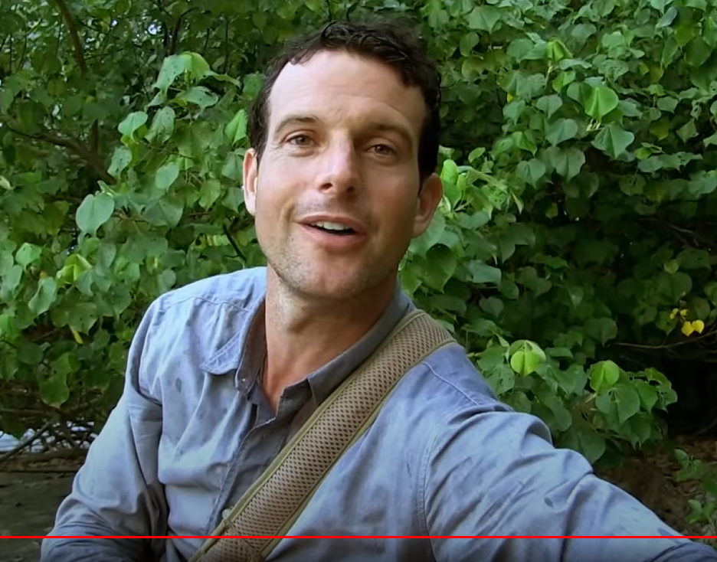

**WILL**

2581.64 2588.64 FARMAR: Andy, Paul and Joe all want to leave this island.

2588.64 2592.64 FARMAR: I'm amazed that they've come this far and want to give up so early.

2600.64 2605.64 HOST As yet another storm hits the island, the men call a crisis meeting.

2605.64 2613.64 PHIL_58: I know it sounds cutthroat, and we need to keep as many of those guys here as we can, but for any of them to change their mind is a win. **TO:CAM**

2614.64 2617.64 FARMAR: There's been so much discussion about people leaving.

2617.64 2622.64 FARMAR: My personal opinion is that we are stronger together than we are apart.

2622.64 2623.64 SPEAKER_10 Agreed. ALL

2623.64 2626.64 WILL: Joe, my hope is that you might have thought differently of a knife.

2626.64 2627.64 JOE_22: I've already had the chat with everyone. **TO: DOE**

2627.64 2628.64 JOE_22: People have already said the thoughts.

2628.64 2632.64 JOE_22: I've already said my thoughts, but on that note, I will be saying no more.

2632.64 2634.64 JOE_22: I'll just be waiting for the boat to arrive and to leave.

2634.64 2635.64 JOE_22: OK?

2637.64 2640.64 FARMER: Paul, would you just let us know how you're feeling at the moment?

2640.64 2646.64 PAUL_36: I came to this island as a bit of a release, you know, to get away from my everyday life. **TO: FARMAR/ ALL**

2646.64 2648.64 PAUL_36: I'm not really confrontational.

2648.64 2650.64 PAUL_36: I don't like having arguments with people.

2650.64 2653.64 PAUL_36: I'd rather just step away from the situation.

2653.64 2666.64 PAUL_36: The final nail in the coffin was to hear somebody say that, it was good that I was going, which I thought was a bit of a shame, but in another way, it confirmed my decision.

2666.64 2669.64 PAUL_36: And in that case, that's why I decided to go.

2669.64 2671.64 CHARLIE: If one goes, there's no point in the other going?

2671.64 2672.64 PAUL_36: Right, here we go.

2672.64 2673.64 CHARLIE: How do we make that decision?

2673.64 2674.64 PAUL_36: Here we go.

2674.64 2676.64 PAUL_36: This is now we're getting to the country.

2676.64 2679.64 PAUL_36: He segregated himself from the group from day one.

2679.64 2681.64 PAUL_36: We're having a discussion. He doesn't want to know.

2681.64 2684.64 PAUL_36: We haven't got any beds. He makes himself a bed.

2684.64 2685.64 PAUL_36: He goes off and sulks.

2685.64 2687.64 PAUL_36: Somehow that's my fault.

2687.64 2688.64 ANDY: I've had no sleep before, Dave.

2688.64 2689.64 PAUL_36: Neither has anybody.

2689.64 2690.64 ANDY: You've had a fault.

2690.64 2691.64 ANDY: You've been sleeping.

2691.64 2693.64 ANDY: Sorry, mate. You've been sleeping.

2693.64 2695.64 PAUL: Andy, nobody's had any sleep.

2695.64 2701.64 PHIL: As a group, no one here has had enough sleep to give them the energy to do what they've had to do the next day.

2701.64 2705.64 PHIL So you pointing a finger at me and saying, well, you've had sleep, fine. That's your problem.

**ANDY TARGETS PHIL**

**Note: Phil does not like Andy after Andy said he was sleeping**

2705.64 2709.64 PAUL_36 I've been having a laugh up until I heard one of my teammates say

2709.64 2712.64 PAUL_36: they wanted me to go. I was having a right crack.

2712.64 2713.64 PAUL_36 Now I'm not.

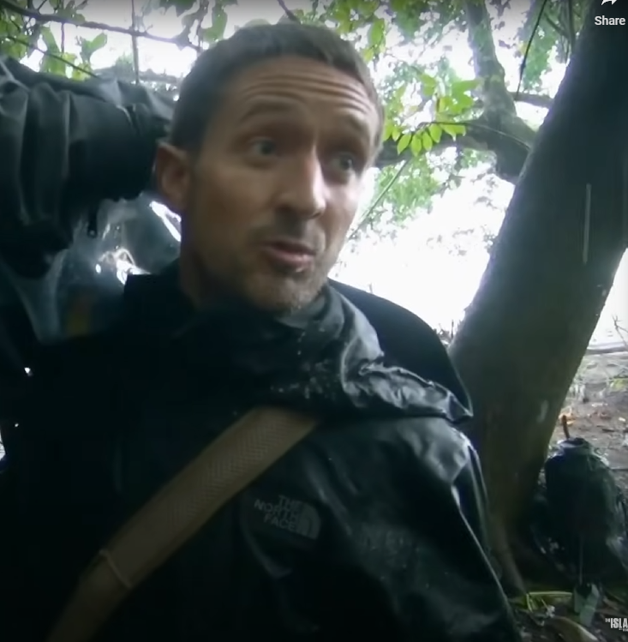

2713.64 2716.64 WILL: In a community, not everyone gets on.

2716.64 2719.64 WILL: And that is a fact of life. We can't change that.

2720.64 2722.64 WILL: So let's build our community.

2722.64 2725.64 WILL: You and you just keep your distance.

2725.64 2727.64 WILL: At least we're together. We're two men up.

2727.64 2731.64 WILL: We can build a shelter in a day rather than taking two days with two men down.

2731.64 2733.64 WILL: The big strong man and the builder.

2733.64 2736.64 WILL: You two fuck off, then we're fucked, aren't we? **TO:ALL**

**Note:** Whoever this guy is the group listened to him

2736.64 2739.64 CHARLIE: See, I don't want to lose two builders, regardless of your character.

2739.64 2742.64 SPEAKER_17 We need you to stay.

2742.64 2745.64 PAUL_36: I'm going to walk away and then that would hopefully...

2745.64 2752.64 PAUL_36: No, listen. So Andy can enjoy his experience and hopefully five, then you're not losing two people, are you?

2752.64 2753.64 PAUL_36: You're losing one.

2753.64 2755.64 ANDY_BENNETT: I'm leaving the island.

2755.64 2757.64 SPEAKER_17: Whether Paul leaves are not.

2757.64 2760.64 ANDY_BENNETT: Whether Paul leaves or not. I would rather Paul stay.

2760.64 2764.64 ANDY_BENNETT: If a strong man and me, he'll be more benefit to you.

2764.64 2767.64 ANDY_BENNETT: But either way, I'm sorry I'm going.

2767.64 2770.64 PAUL_36: For him to fucking say, I'm glad he's going.

2770.64 2776.64 PAUL_36: Good, then I'll stay, then all of a sudden he hasn't got his own way again and it's, oh, I'm going, there's other reasons.

2776.64 2778.64 PAUL_36: It's fucking immaturity.

2778.64 2781.64 PAUL_36: It's soaking and it's detention seeking.

2781.64 2783.64 PAUL_36: And you don't want to be scapegoat. I really like this.

2783.64 2789.64 PAUL_36: I'm not having it. I am going off this island because I'm not being held responsible for that.

2789.64 2791.64 PAUL_36: End of story.